ACCOMMODATION FORM VICTOR CYPRUS U17 INTERNATIONAL 2025

All reservations must be sent to:
badminton@cytanet.com.cy

CLOSING DATE FOR ACCOMMODATION BOOKING: November 21, 2025

National Association:
Name of Contact Person:
Tel. No:
Fax No:
E-mail:
Preferred Hotel (Choose Asty or Altius)

Please fill out the accommodation form and send to badminton@cytanet.com.cy In the accommodation form, please choose one of the following 2 official hotels:

Accommodation closing date: 21 November 2025

Note: All accommodation reservations will be treated on a first-come first-served basis. There is a limited number of rooms available. Payment needs to be settled directly with the hotel.

ASTY Hotel **

12 Prince Charles Str, PO Box 24502, 1300, Nicosia, Cyprus,

 | B/B | Half Board
Single room | 70€ | 85€
Double room | 95€ | 125€
Triple room | 125€ | 170€
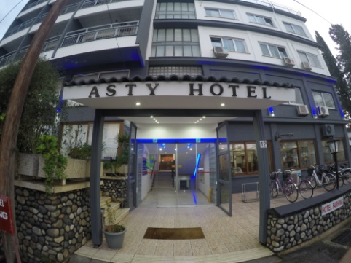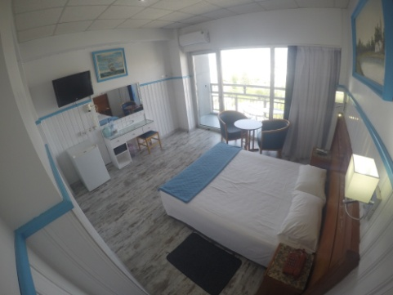
NAME | SURNAME | Room Type  Single, Double or Triple | Terms of Stay (B/B, Half Board or F/B) | Sharing room with | Arrival Date | Depart Date

Note: Please note that rooms will be given out on a first come, first served basis because of limited number of rooms available!
PAYMENT FOR ACCOMMODATION MUST BE SETTLED DIRECTLY WITH THE HOTEL!
*The organizer will provide transportation from the official hotels to the venue for persons booking their accommodation from the Cyprus Badminton Federation.*
Accommodation closing date: 21 November 2025

ALTIUS BOUTIQUE Hotel ****

1 Acheon Street
1101 Nicosia, Cyprus

 | B/B
Single room | 80€
Double room | 120€
Triple room | 140€
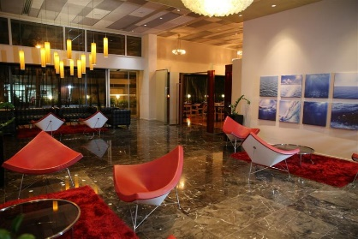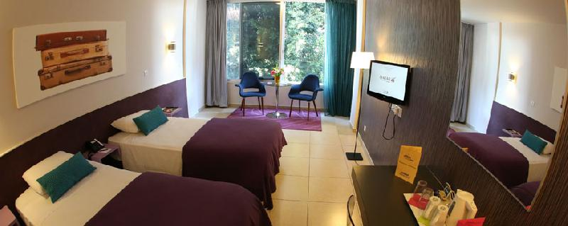

NAME | SURNAME | Room Type  Single, Double or Triple | Terms of Stay (B/B, Half Board or F/B) | Sharing room with | Arrival Date | Depart Date

Note: Please note that rooms will be given out on a first come, first served basis because of limited number of rooms available!
PAYMENT FOR ACCOMMODATION MUST BE SETTLED DIRECTLY WITH THE HOTEL!
*The organizer will provide transportation from the official hotels to the venue for persons booking their accommodation from the Cyprus Badminton Federation.*
Accommodation closing date: 21 November 2025

TRAVEL DETAILS FORM

Please email the travel details form to badminton@cytanet.com.cy
by 21 November 2025

Arrival to Larnaca International Airport
Date: | Time: |  | am/pm
Airline: | Flight No/Origin:
No. of persons:

Names:

Departure from Larnaca International Airport
Date: |  | Time: | am/pm
Airline: |  | Flight No/Destination:
No. of persons :

Names:

